**Practical Number 1: Design a Web Application for an Organization with Registration forms and advanced controls.**

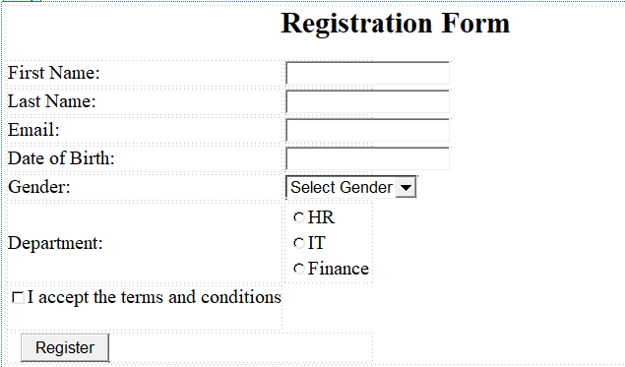

**Default.aspx**

<%@ Page Language="C#" AutoEventWireup="true" CodeBehind="Default.aspx.cs" Inherits="Experiment_Number_1.Default" %>

<!DOCTYPE html>

<html xmlns="http://www.w3.org/1999/xhtml">

<head runat="server">

<title>Registration Form</title>

</head>

<body>

<form id="form1" runat="server">

<div>

<h2>Registration Form</h2>

<table>

<tr>

<td><label for="txtFirstName">First Name:</label></td>

<td><asp:TextBox ID="txtFirstName" runat="server" CssClass="form-control"></asp:TextBox></td>

</tr>

<tr>

<td><label for="txtLastName">Last Name:</label></td>

<td><asp:TextBox ID="txtLastName" runat="server" CssClass="form-control"></asp:TextBox></td>

</tr>

<tr>

<td><label for="txtEmail">Email:</label></td>

<td><asp:TextBox ID="txtEmail" runat="server" CssClass="form-control"></asp:TextBox></td>

</tr>

<tr>

<td><label for="txtDOB">Date of Birth:</label></td>

<td><asp:TextBox ID="txtDOB" runat="server" TextMode="Date" CssClass="form-control"></asp:TextBox></td>

</tr>

<tr>

<td><label for="ddlGender">Gender:</label></td>

<td>

<asp:DropDownList ID="ddlGender" runat="server" CssClass="form-control">

<asp:ListItem Text="Select Gender" Value=""></asp:ListItem>

<asp:ListItem Text="Male" Value="Male"></asp:ListItem>

<asp:ListItem Text="Female" Value="Female"></asp:ListItem>

<asp:ListItem Text="Other" Value="Other"></asp:ListItem>

</asp:DropDownList>

</td>

</tr>

<tr>

<td><label>Department:</label></td>

<td>

<asp:RadioButtonList ID="rblDepartment" runat="server">

<asp:ListItem Text="HR" Value="HR"></asp:ListItem>

<asp:ListItem Text="IT" Value="IT"></asp:ListItem>

<asp:ListItem Text="Finance" Value="Finance"></asp:ListItem>

</asp:RadioButtonList>

</td>

</tr>

<tr>

<td>

<asp:CheckBox ID="chkTerms" runat="server" Text="I accept the terms and conditions" />

</td>

</tr>

<tr>

<td colspan="2">

<asp:Button ID="btnSubmit" runat="server" Text="Register" OnClick="btnSubmit_Click" />

</td>

</tr>

</table>

</div>

</form>

</body>

</html>

**Default.aspx.cs**

using System;

using System.Collections.Generic;

using System.Linq;

using System.Web;

using System.Web.UI;

using System.Web.UI.WebControls;

namespace Experiment_Number_1

{

public partial class Default : System.Web.UI.Page

{

protected void Page_Load(object sender, EventArgs e)

{

}

protected void btnSubmit_Click(object sender, EventArgs e)

{

if (chkTerms.Checked)

{

string firstName = txtFirstName.Text;

string lastName = txtLastName.Text;

string email = txtEmail.Text;

string dob = txtDOB.Text;

string gender = ddlGender.SelectedValue;

string department = rblDepartment.SelectedValue;

// Display confirmation message

Response.Write($"<h3>Registration Successful!</h3>");

Response.Write($"<p>Name: {firstName} {lastName}</p>");

Response.Write($"<p>Email: {email}</p>");

Response.Write($"<p>Date of Birth: {dob}</p>");

Response.Write($"<p>Gender: {gender}</p>");

Response.Write($"<p>Department: {department}</p>");

}

else

{

Response.Write("<h3 style='color:red'>Please accept the terms and conditions.</h3>");

}

}

}

}

